**MATHEMATICS SPECIALIST UNIT 3&4 Name_______________**

**TEST 5, 2018**

**Section One: Resource Free**

Reading time: 2 minutes Time: 22 minutes Total marks: 22 ________________________________________________________________________________________

Question 1 (4 marks)

A differential equation is defined as 

(a) Find the gradient  at  for the values in the table below. (2 marks)

|  |  |  |  |  |  |
| --- | --- | --- | --- | --- | --- |
| x | -2 | -1 | 0 | 1 | 2 |
| y | 1 | 1 | 1 | 1 | 1 |
|  |  |  |  |  |  |

(b) Sketch the direction field for  on the set of axes below. (2 marks)

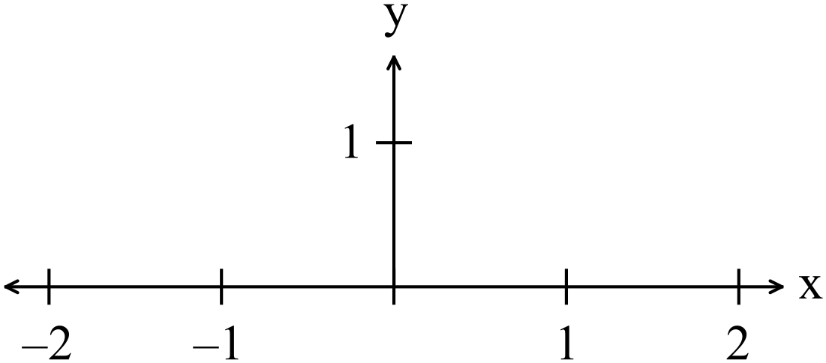

**Question 2 (8 marks)**

Determine a general solution to the following differential equations:

(a)  (2 marks)

(b) = (2 marks)

(4 marks)

(c) $\frac{dy}{dx}=\frac{1}{{x^{2}+10x+16}^{ }}$ (4 marks)

Question 3 (7 marks)

(a) Find the expression for given the relationship  (4 marks)

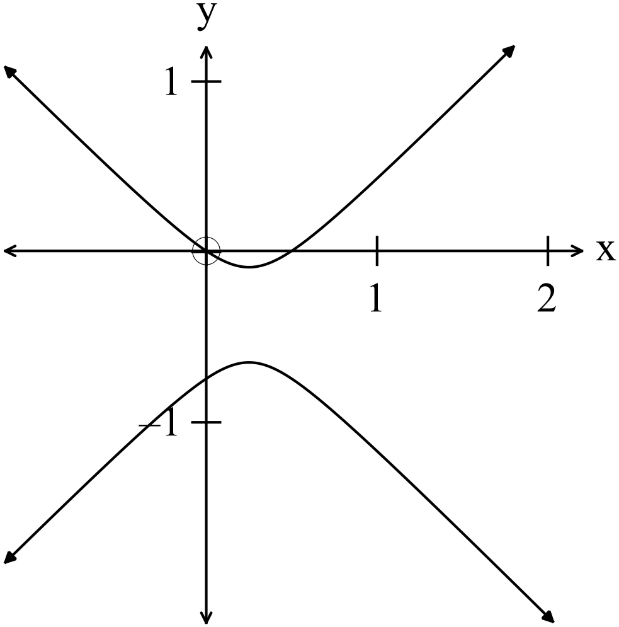

(b) Hence find  where x = 0. (3 marks)

Question 4 (3 marks)

For every degree Celsius the temperature increases in a given range, the radius of ball

bearings in an engine increase by 0.01 mm.

If the temperature of the engine increases one degree Celsius (in the given range) and the ball bearings had a radius of 1.5 cm immediately before the temperature increase, use a calculus method to determine the corresponding increase in volume of the ball bearings.

**MATHEMATICS SPECIALIST UNIT 3&4 Name_______________**

**TEST 5, 2018**

**Section One: Resource Rich**

Reading time: 2 minutes Time: 40 minutes Total marks: 38 ________________________________________________________________________________________

Question 5 (2 marks)

An oil spill is spreading in a circular fashion such that the radius is increasing at a

rate of $\frac{1}{r}$*m/minute*

Show that the area is increasing at a constant rate.

Question 6 (7 marks)

Assuming that the rate of cooling of a body is proportional to the temperature difference between the body and the medium it is contained in is given by the differential equation



where T° K is the temperature of the body and t is the time in minutes.

(a) If the original temperature of the body is T = 150° K, the surrounding medium is

100° K, use the above constraints to show that the equation for the temperature of the body is

T(t) = 100 + 50e-kt where t is in minutes and T is in °K (3 marks)

(b) Given that the body cools to 135° K in 10 minutes evaluate k to 4 d.p. (2 marks)

(c) What is the temperature after 20 minutes? (1 mark)

(d) How long, to the nearest minute, will it take for the body to cool to 120° K?

(1 marks)

Question 7 (12 marks)

An inverted right cone of diameter 80 cm and height 20 cm is being filled with water at a constant rate of cm3 per second. Initially the cone contains cm3 of water. Let $r$ be the radius of the surface of the water and $h$ be the depth of water after $t$ seconds.

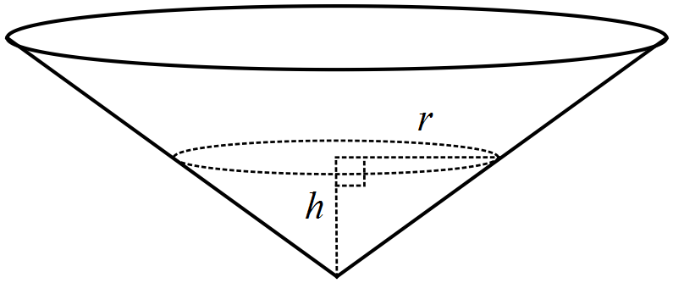

(a) Show that the relationship between the volume of water in the cone, cm3, and the radius is given by $V=\frac{π}{6}r^{3}$. (2 marks)

(b) Show that $\begin{matrix}dr \\ \overline{dt}\end{matrix}=\begin{matrix}6 \\ \overline{r^{2}}\end{matrix}$. (2 marks)

(c) Determine the rate of change of radius $r$ when $t=4$. (2 marks)

(d) Use the differential equation from (b) to determine a relationship between the radius $r$ and time $t$. (4 marks)

(e) Calculate the time required to completely fill the cone. (2 marks)

Question 9 (9 marks)

A first-order differential equation has a slope field as shown below.

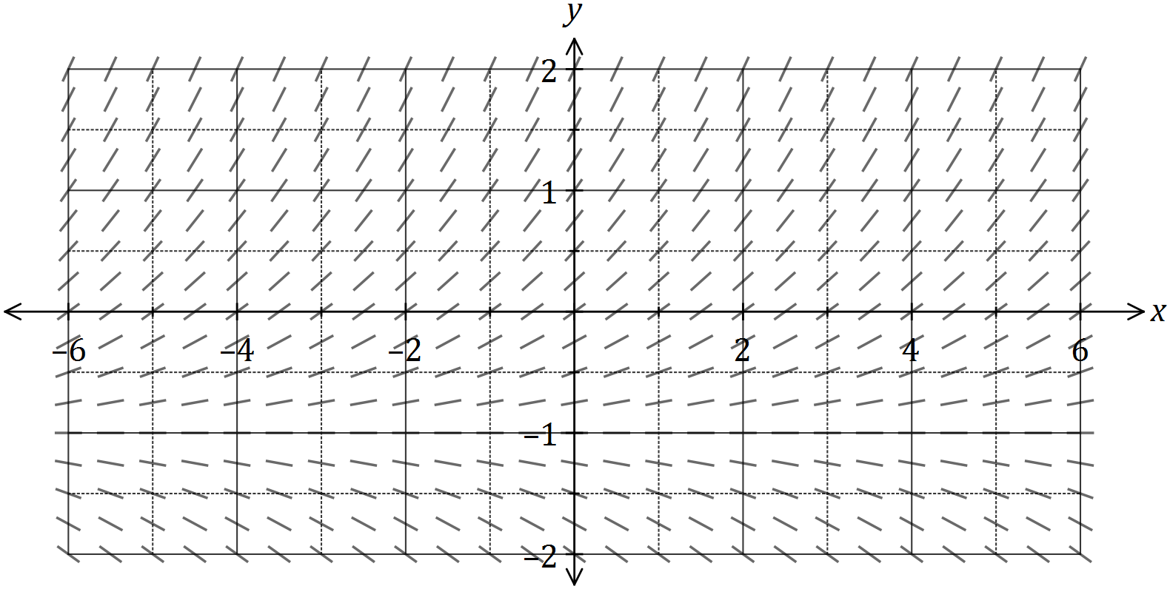

(a) Sketch the solution of the equation that passes through $P(3, 0)$, where the value of the slope is $0.5$. (3 marks)

(b) The general differential equation for the slope field is of the form below, where $a$ and $b$ are constants:

$$\frac{dy}{dx}=a(y+b)$$

Determine the solution to this equation that passes through $P$ in the form $y=f(x)$.

(6 marks)

Question 10 (8 marks)

Carnac Island now has a population of tiger snakes. 40 tiger snakes were put on the island in 1930.

A study was made of the population of the snakes and it was found that the number can be estimated by the equation  where  is in years taken from 

(a) Estimate the number of tiger snakes on Carnac Island in (2 marks)

(i) 1964.

(ii) 2015.

(b) Determine the capacity of the island to support tiger snakes i.e. the maximum number of snakes that can live on the island. Explain. (2 marks)

(c) Find the rate of increase of snakes in 1990 and suggest whether the rate of increase is increasing or decreasing at that time. (4 marks)